**SkyBox Web Configuration Page**

**User Manual**

The web configuration page enables users to adjust the settings of the Skybox, including network, Modbus, and cloud configurations**.**

**Before You Begin:**

* ***Please make sure to go through the “Best Practices” section at the end of the document to ensure your changes are saved!***
* ***Please connect the skybox to a network using an ethernet cable before connecting the Skybox to a power source***
* **Make sure your skybox is connected to both ethernet and power before accessing webconfig controls**

**Finding the IP address assigned to the device:**

The Web Configuration page can be accessed by using an IP address on the browser. By default, the Skybox operates in DHCP mode, allowing the router to automatically assign an IP address. Using this assigned IP address, the page can be accessed at **http://<ip_address>:80**

***\*Be sure to add “:80” after your IP address otherwise it will not work.\****

1. **SkyCentrics APP Portal Method:**

Create or log in to your account on the [SkyCentrics APP portal](https://app.skycentrics.com/auth/login)

Hit **“+ Add”** button in top right corner of your dashboard

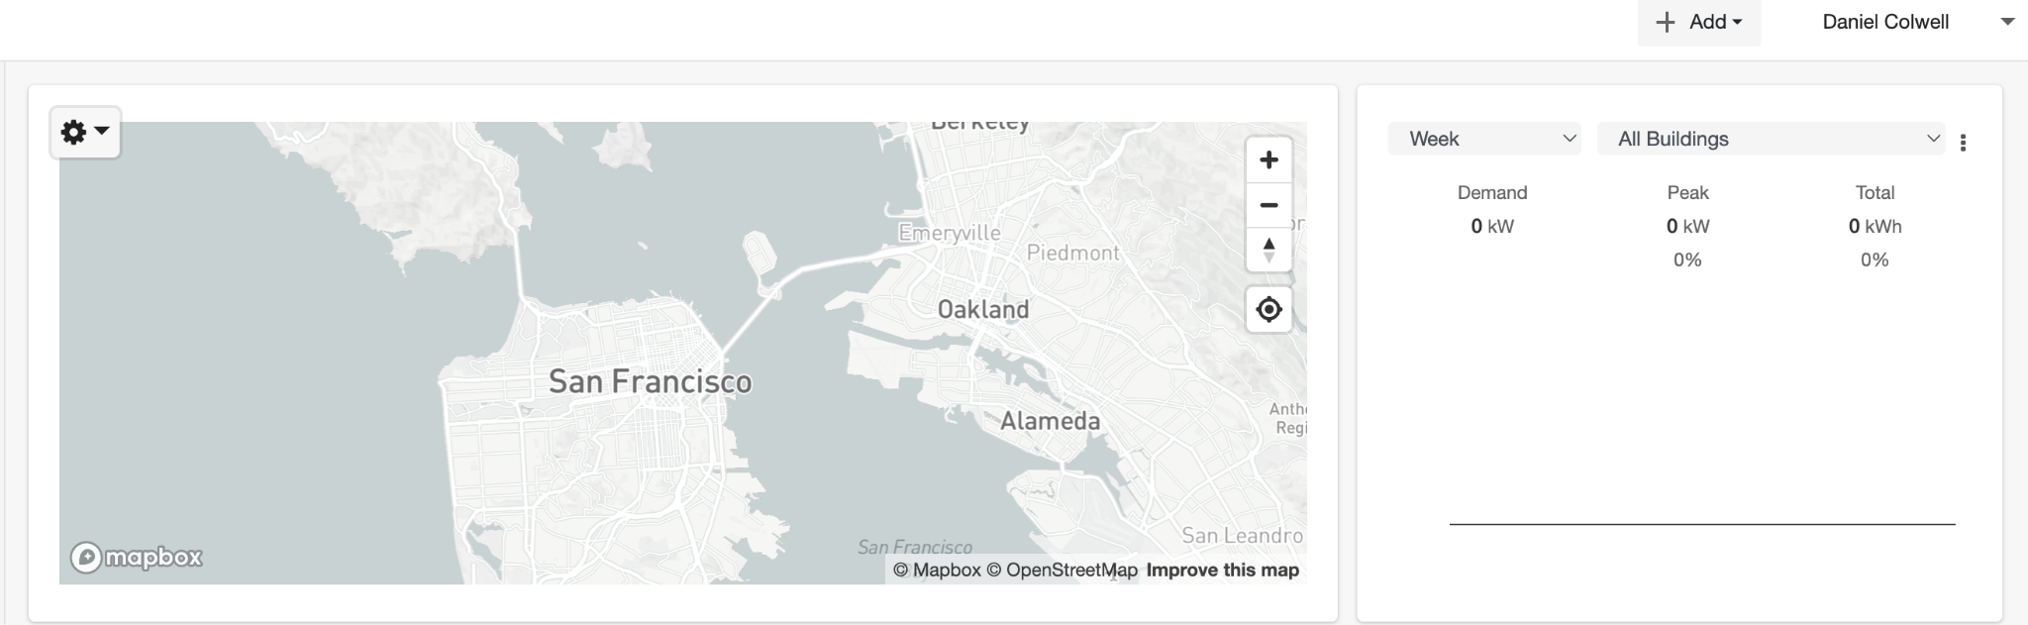

Choose **“add device”** - you should see the window below. Name your device and put it in a group of your choosing. **Ensure your device type is “SkyBox”.** Enter in the serial number located on the side of your SkyBox. It will look something like “FCC23DXXXXXX”- the code will be 000000.

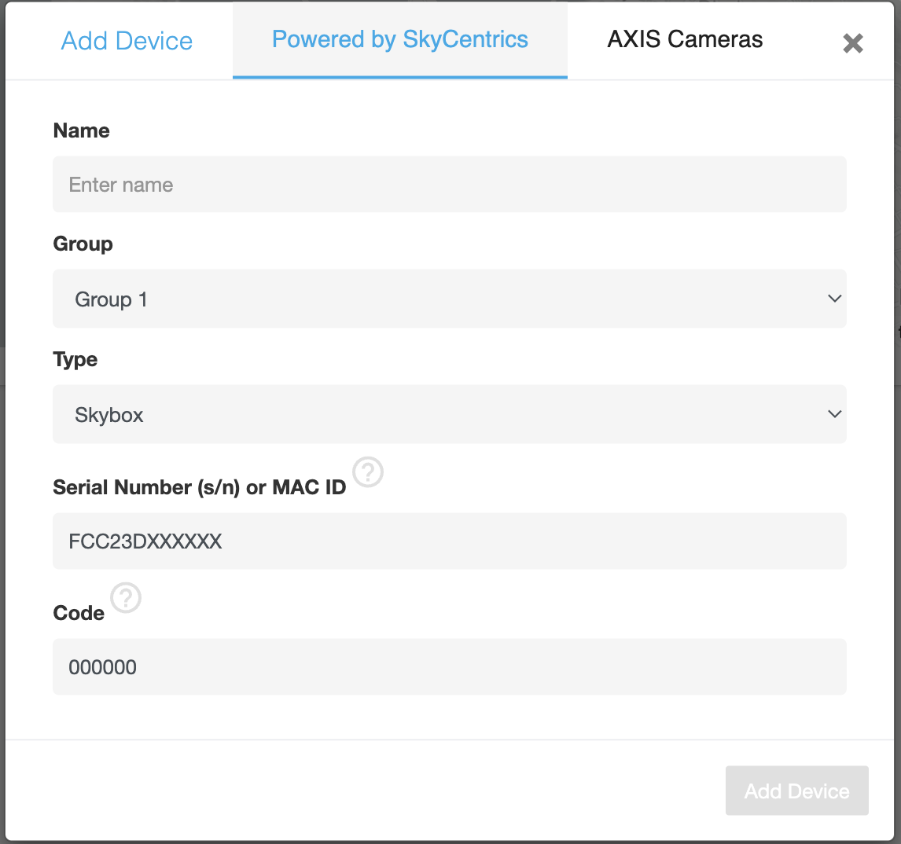

Your device should successfully be added to the APP portal, and the ip address will be visible in the **“overview”** tab.

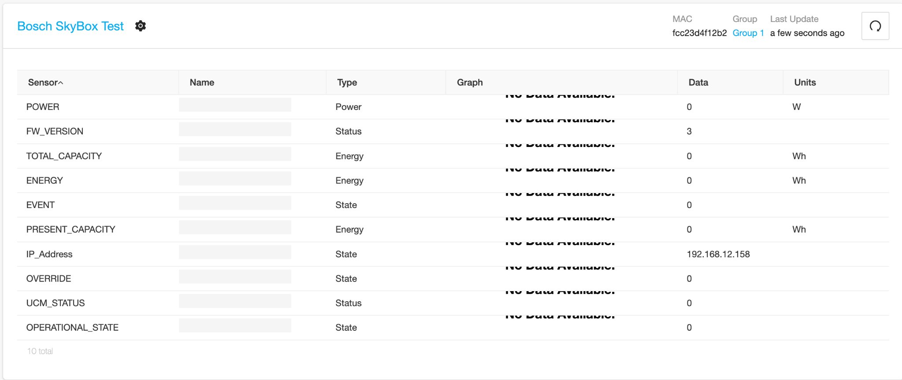

1. **Terminal/Command Line Method (No Account on APP Portal):**

Go to Terminal (If using a MAC) or Command Line if using Windows.

Type “arp -a” and hit ‘enter’ key. ***Ensure there is a space when you type “arp -a”. “arp-a” will not work***

You will find a list of devices on your network with corresponding IP addresses. Look for the mac address that corresponds to the serial number of your SkyBox with ‘:’ interspersed. The serial number can be found on the label of the Skybox under “s/n”

**Example:** If the serial number of Skybox box as shown above is FCC23D4F0A08, then find the **IP address** (Numbers in parentheses on the left) corresponding to the “fc:c2:3d:4f:a:8” on the right.

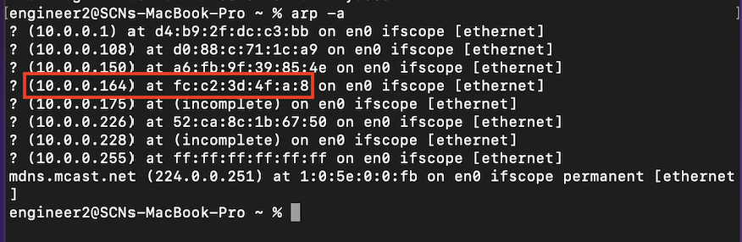

The IP address in this case would be http://**10.0.0.164**:80.

**Accessing Webconfig Page**

Copy **The IP Address** (the numbers in parentheses on the left) into your browser, **being sure to add “:80” to the end of the address.**

When accessing the page, users must first provide authentication details, including a username and password, to sign in.

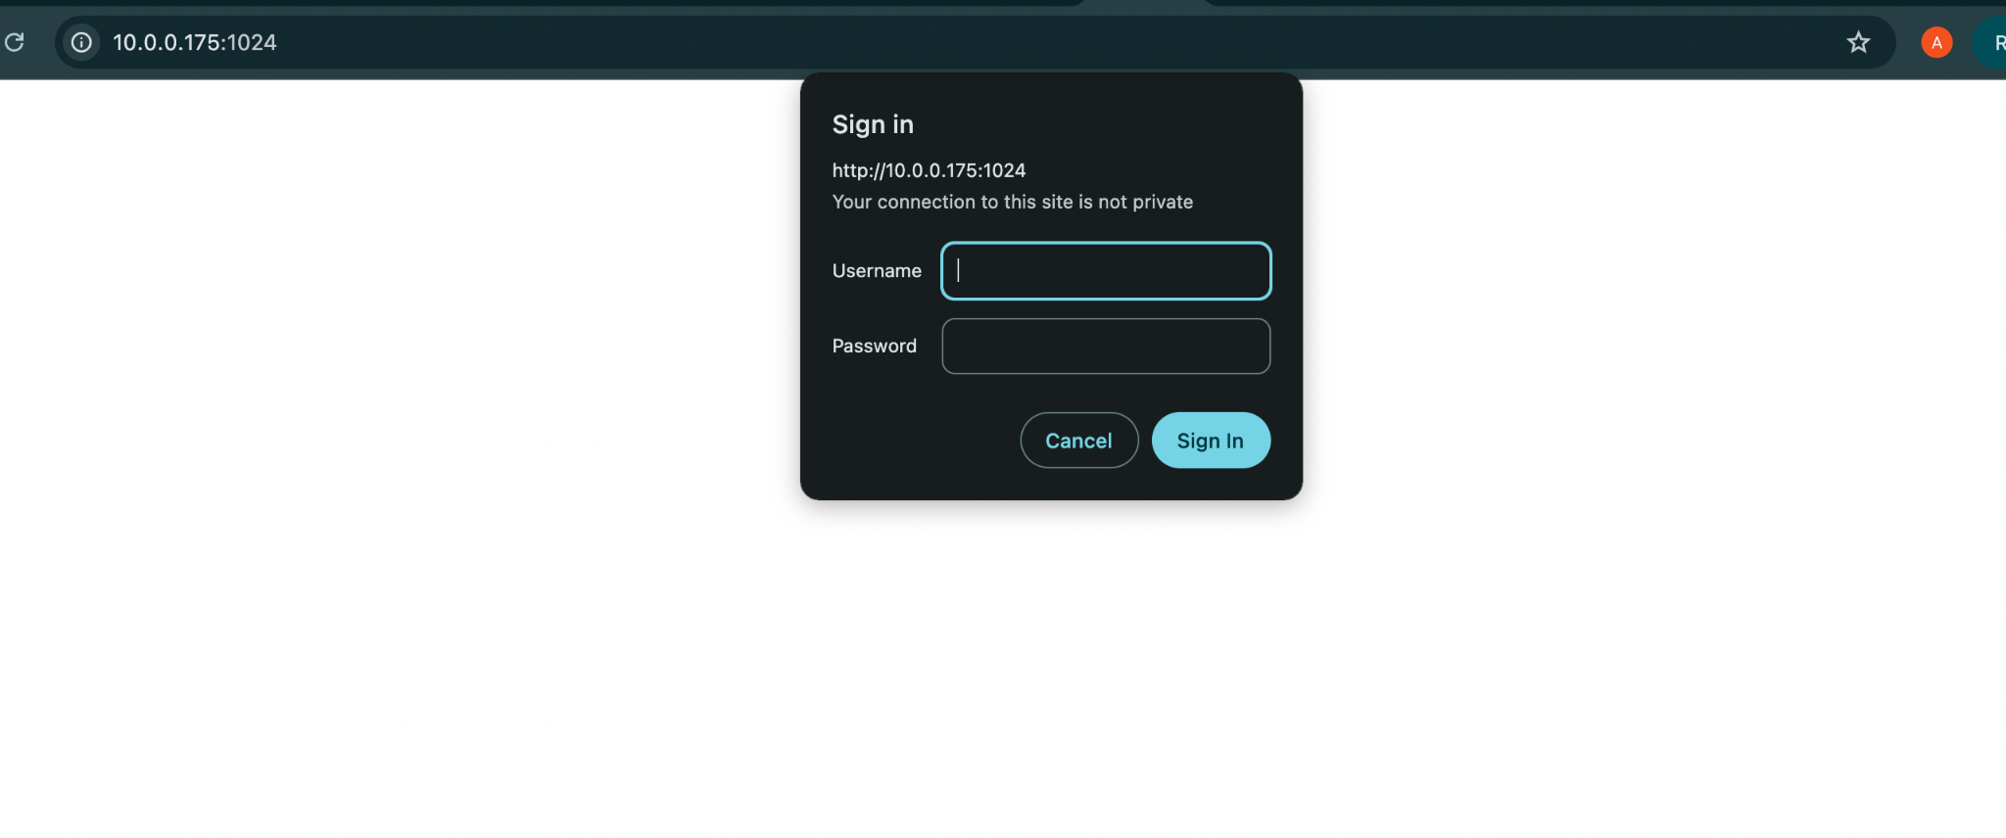

**Instructions for Authentication:**

* The username is set as **‘admin’**.
* The password is the **Serial Number** of the Skybox which can be found on the label of Skybox (Marked in red below).

For example, the password in this case would be FCC23D4F14ED

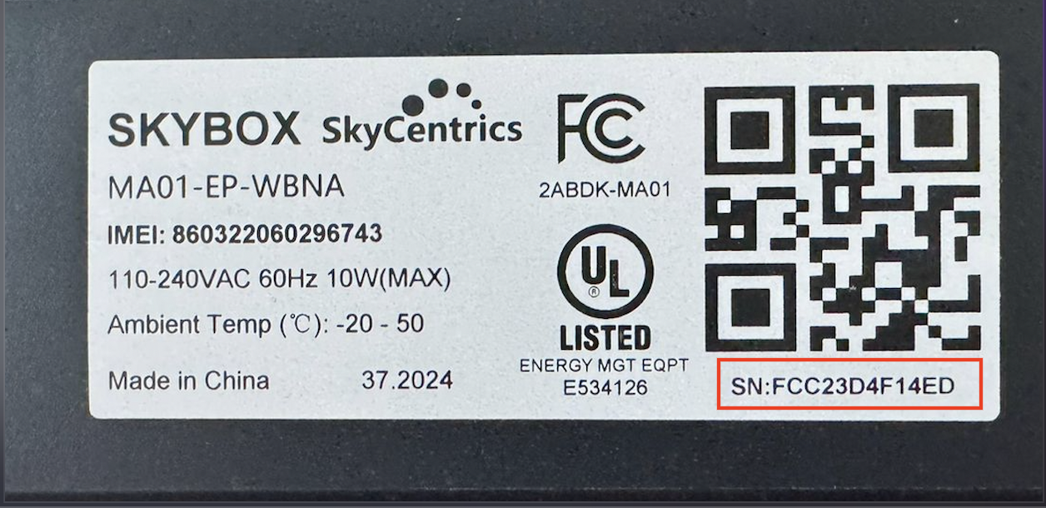

Once authenticated, the web configuration page will load.

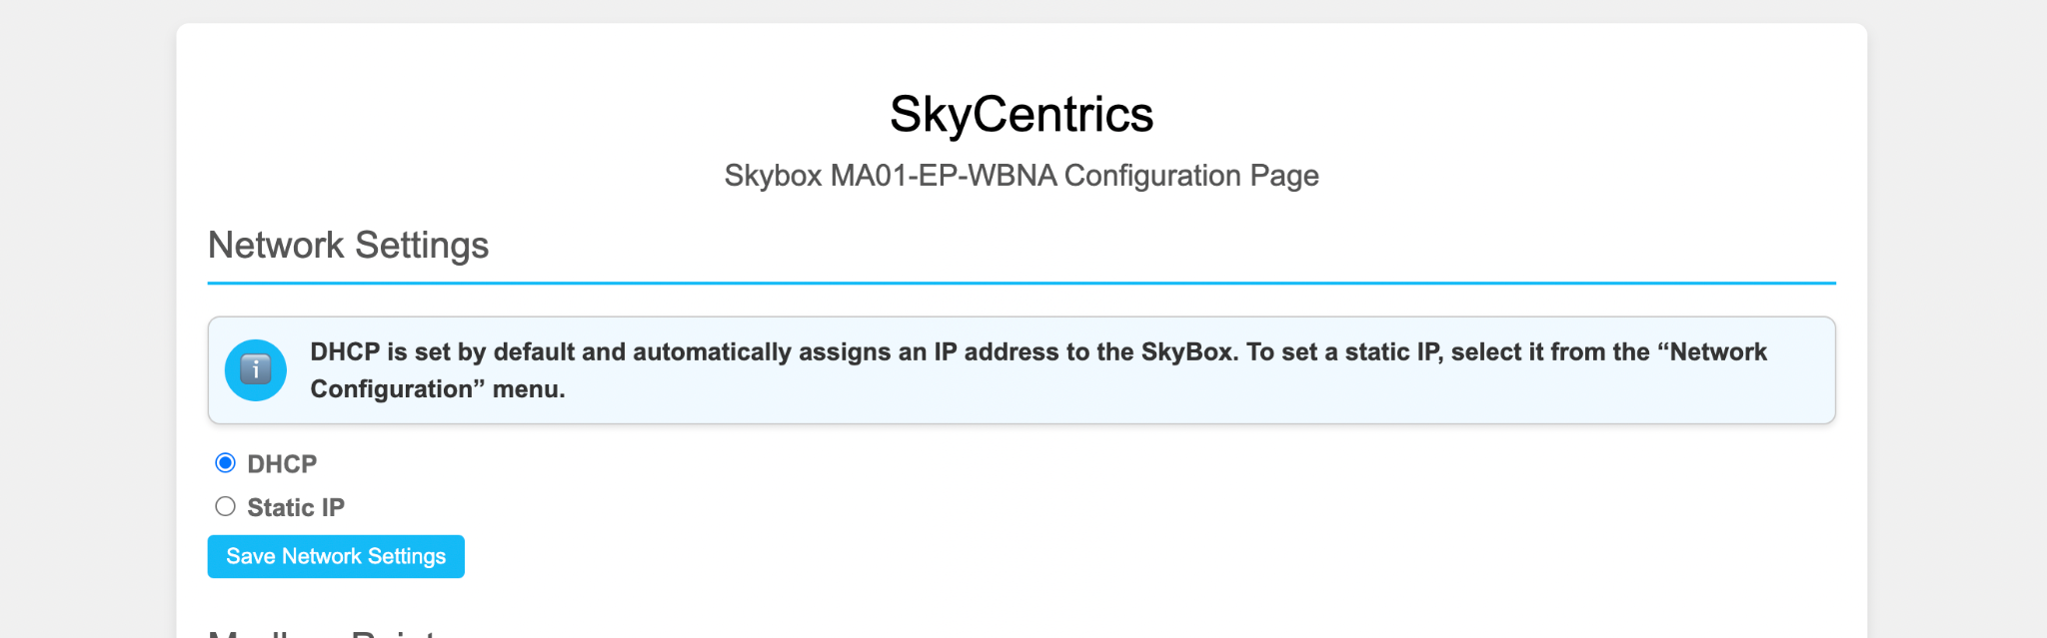

**Network Settings**

To configure a static IP address, select the "Static IP" option. This will allow users to manually input the IP address, gateway, subnet mask, and DNS settings.

Once the desired configurations have been entered, click the "Save Network Settings" button to save the changes made.

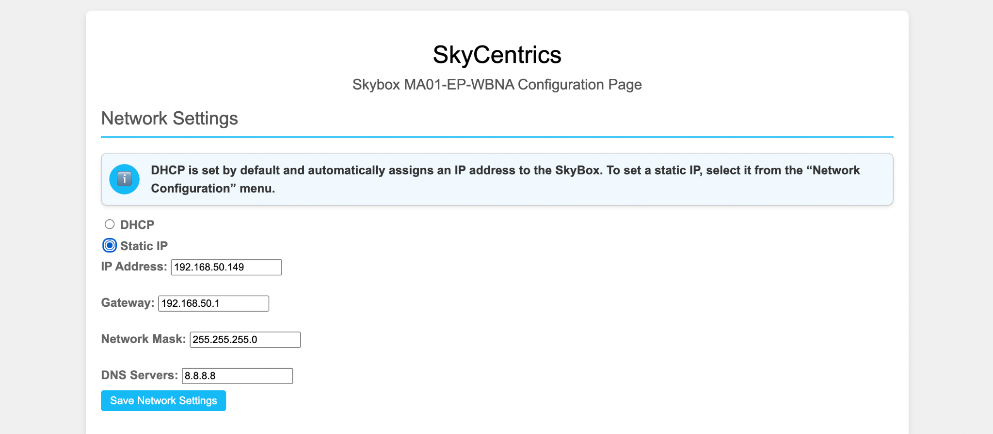

Afterthe Skybox is restarted, the device will utilize the set static IP address. The Skybox can be restarted by clicking on the ‘Apply Changes’ button at the bottom of the web configuration page.

**Please note :** Since the IP address has changed, the webpage has to be accessed with the newly set IP address.

**Modbus Settings**

The Modbus settings section of the web configuration page allows users to configure the Skybox to operate in two modes: **Server** and **Client**.

**1. Server Mode**In Server mode, which is the default setting, the Skybox functions as a Modbus server, making its data available via Modbus protocol. Users can view the available Modbus points directly on the web configuration page.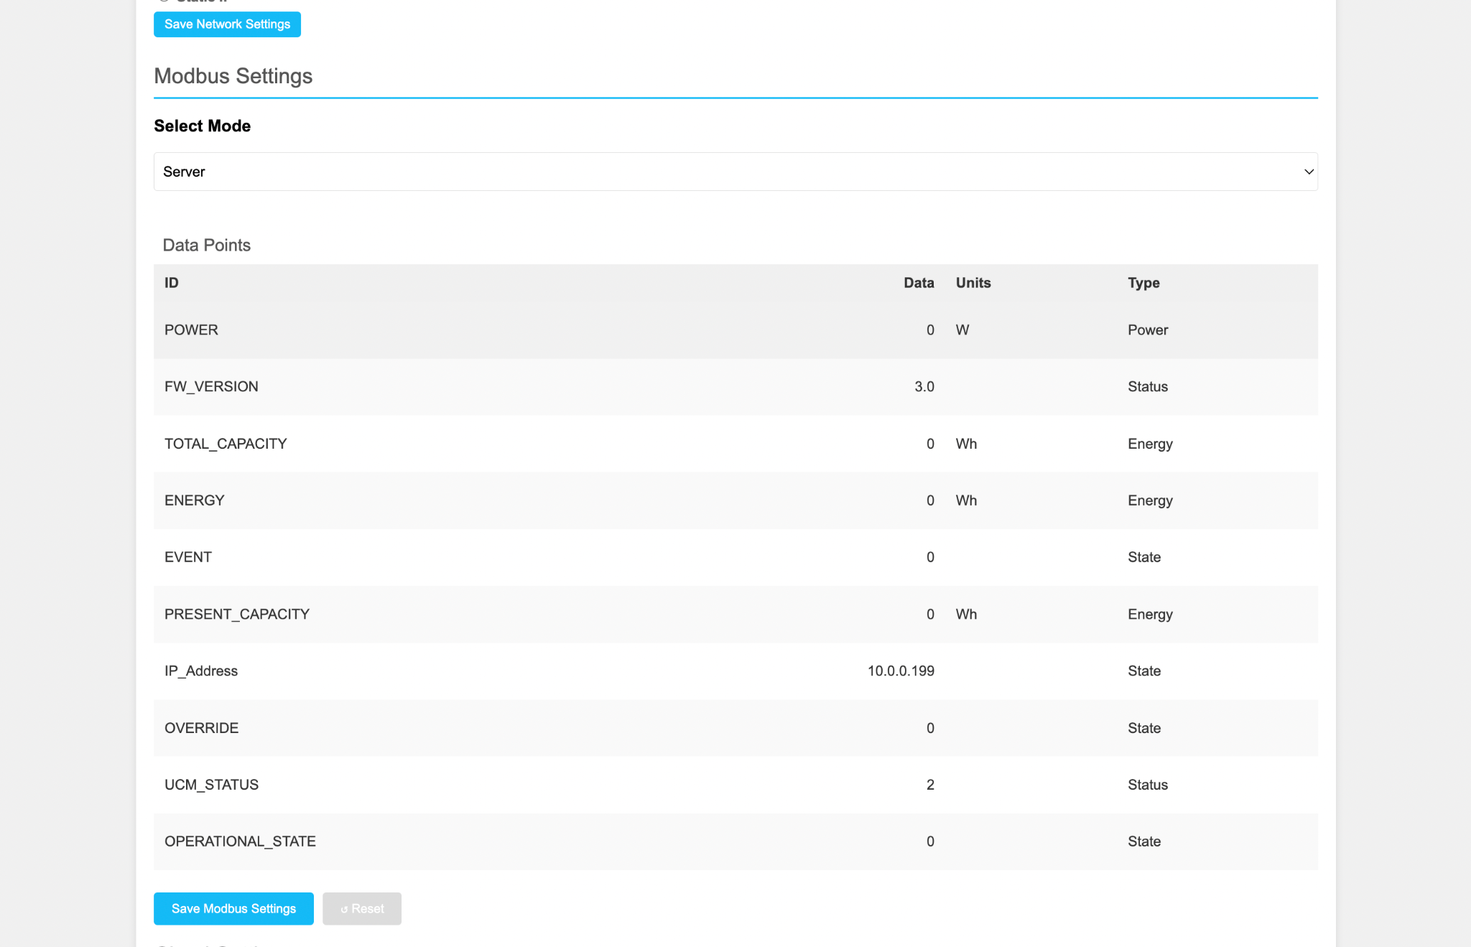

The device's IP address, which also serves as the hosting address for the webpage, is also displayed in the table.

**2. Client Mode**

To configure the Skybox in Client mode, users can select this option from the dropdown menu.

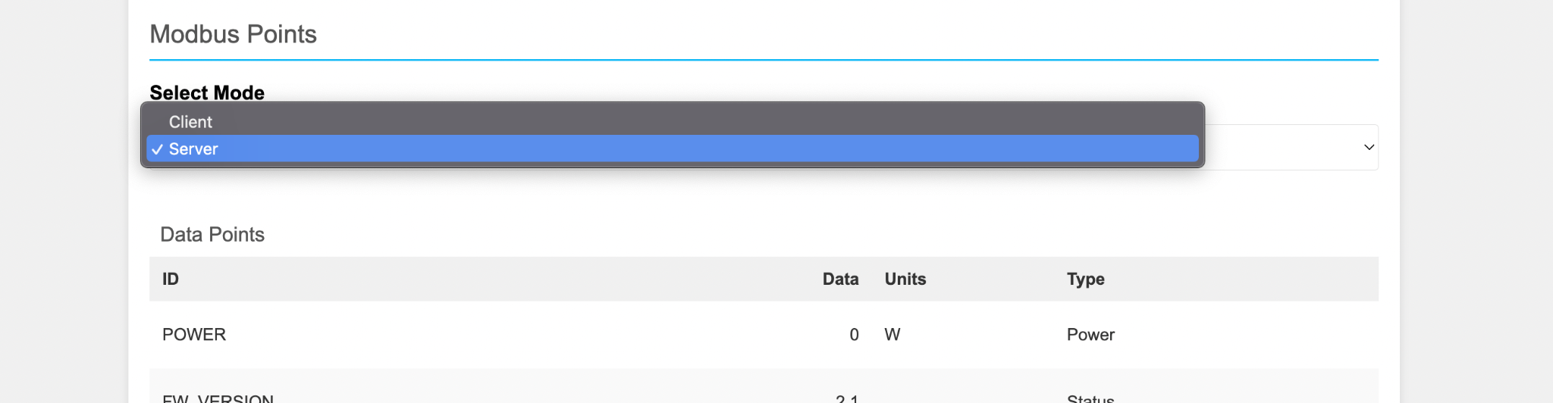

In Client mode, users can specify custom Modbus points using which the Skybox will retrieve data from a Modbus server. The server details, including the IP address and port, can be entered in the corresponding input fields as illustrated below.

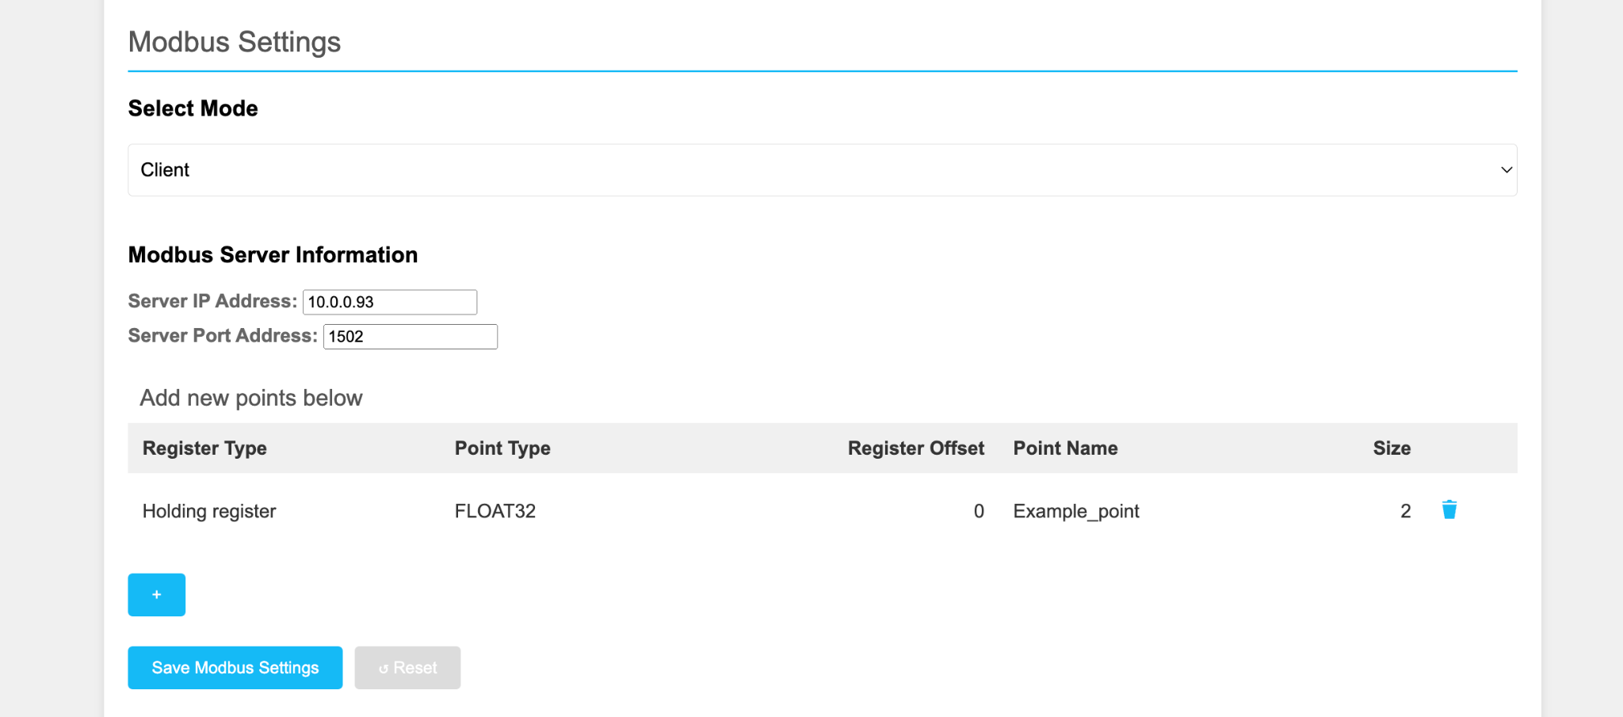



The button can be used to add Modbus points to the list.

Users can input the Register Type, Data Type, Register offset Address into the provided form. The Skybox uses this form to retrieve data from the specified Modbus server, when operating in Client mode.

**Please click on the Save Modbus Settings button finally after adding / deleting points.**

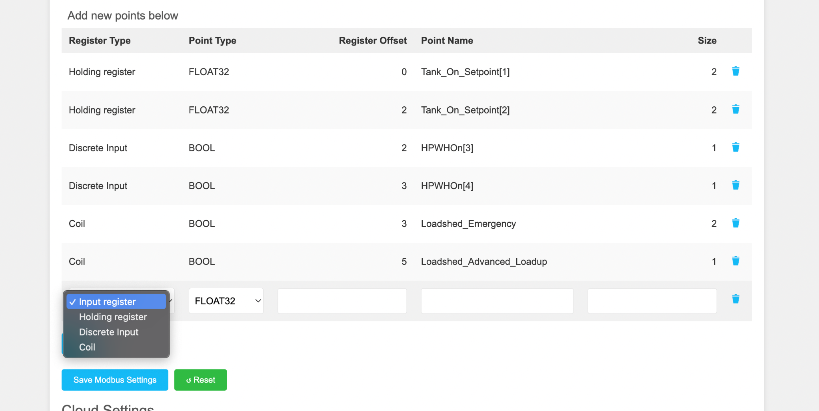

After configuring all the required details, click on **'Save Modbus Settings'** to save the settings. The changes will be applied once the Skybox has restarted.

**Cloud Settings**

The Cloud Settings form allows users to enable data transmission to the cloud. The data being sent to cloud is:

* In case of server mode, the Skybox default points are transmitted to the cloud
* In case of client mode, the information that is accessed using the custom Modbus points list, procured from an external Modbus server will get transmitted to the cloud.

Additionally, the frequency at which the data should be sent can be specified.

The minimum frequency that can be set is 10 seconds and maximum is one hour.

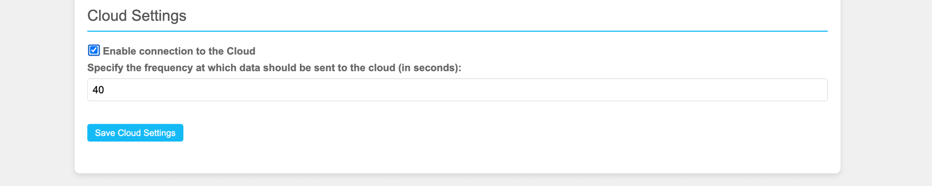

Click the 'Save Cloud Settings' button to save the configuration.The changes will be applied once the Skybox is restarted.

**Water heater Simulator**

The Water heater settings form allows the user to enable the Skybox to simulate a Water heater. The checkbox has to be clicked on to enable it.

The Save WH settings button has to be clicked to save the choice.

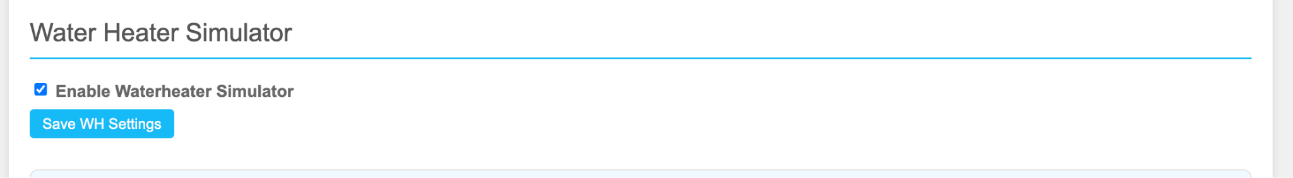

**Saving Changes:**

**Finally, to apply all the changes and restart the skybox, click on the ‘Apply Changes’ button at the bottom of the web configuration page.**

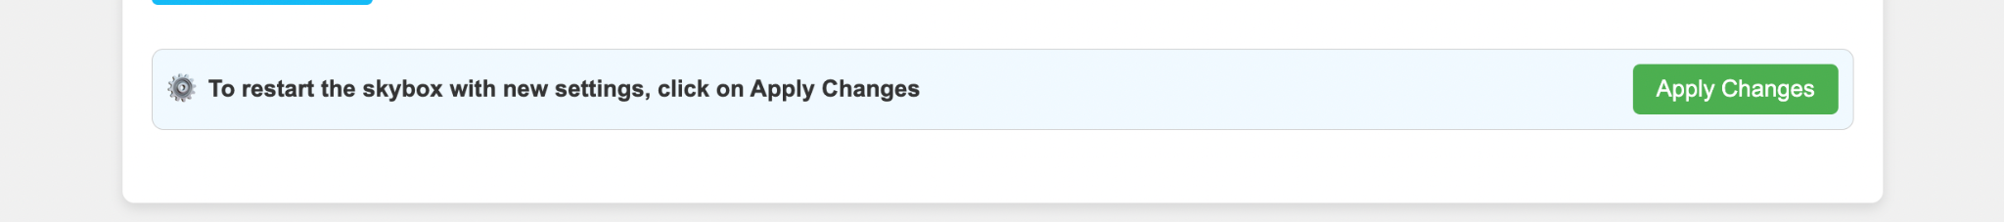

After clicking the **Apply changes button, please wait for the Skybox to reboot and for the page to be reloaded automatically. It will take around 45 seconds - 1 minute**.

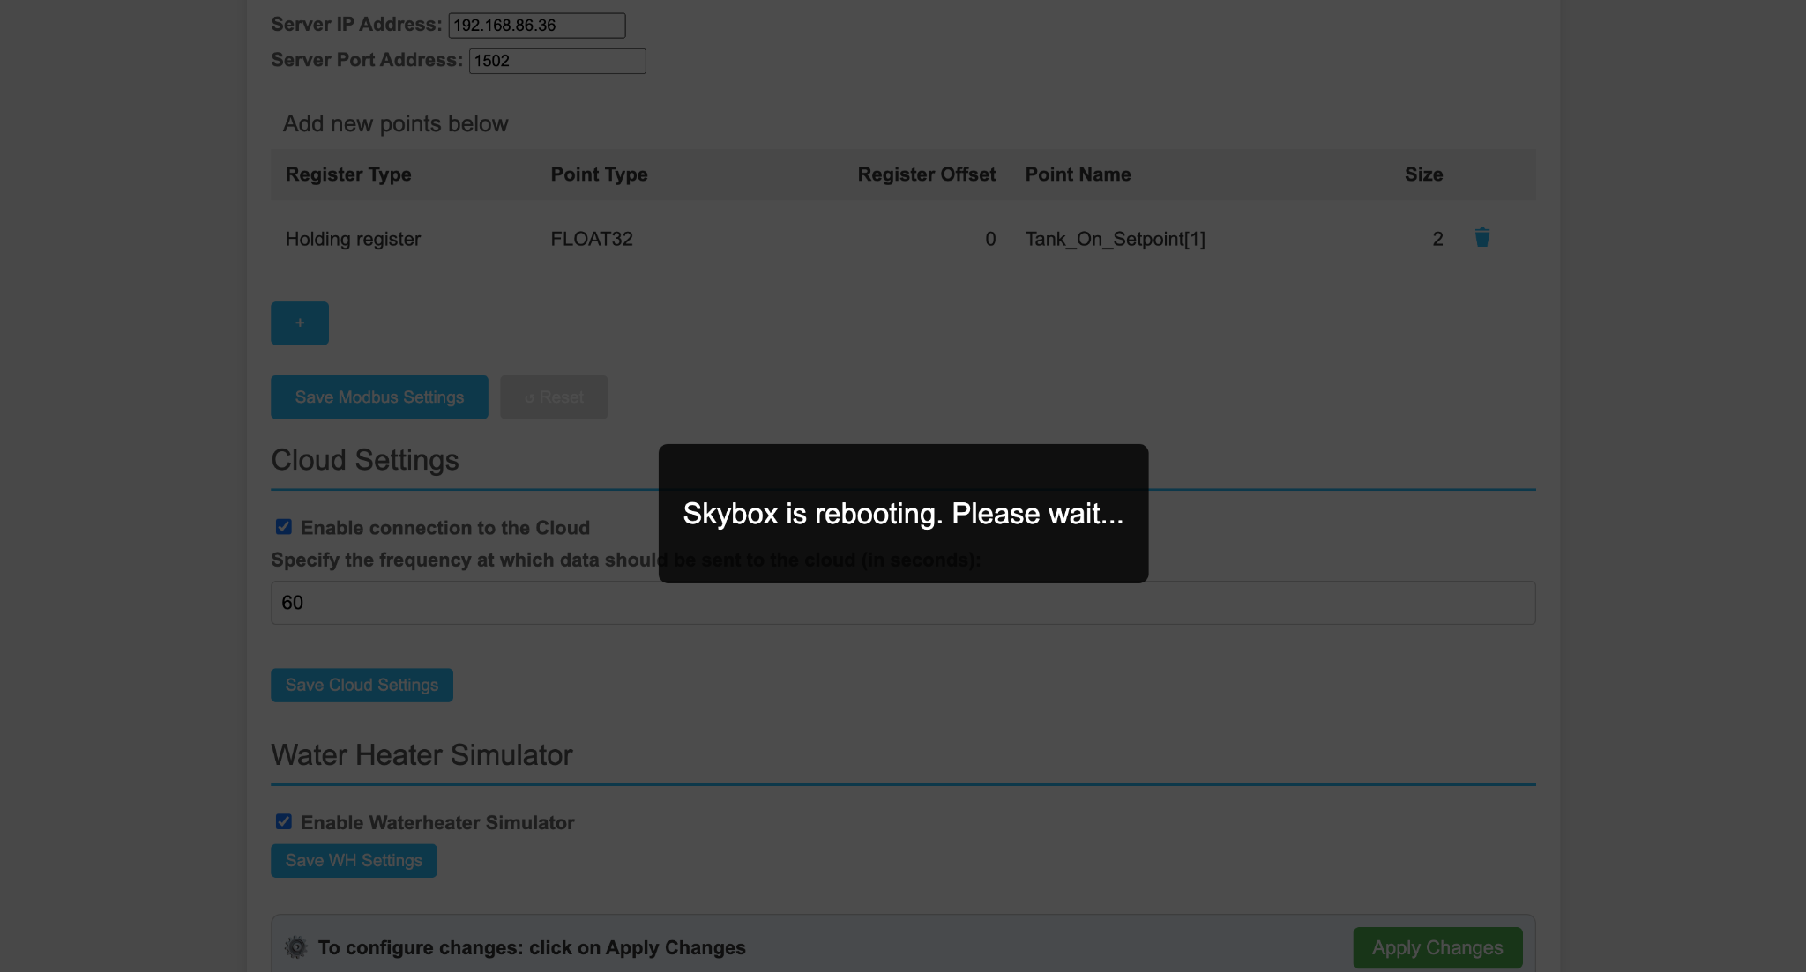

**Reset button on Skybox:**

A button is present next to the ethernet port. This can be used to reboot the skybox or reset it to original settings

1. If the button on the Skybox is pressed for 3-4 seconds, the user can reset the Skybox to original/ default settings ( DHCP mode, Modbus Server mode, WH simulator OFF ,Cloud ON )

Please remember to manually refresh the webpage if it was in use prior to pressing the button to view the webpage with new settings after reset

1. If the user presses the button for more than 5 seconds, the Skybox reboots (same function as Apply changes button on webpage)

**Best Practices:**

* The corresponding ‘save settings’ button of each section must be clicked on after making changes.
* For settings changes to take effect, the Skybox must be rebooted.
* The SkyBox does not have to be rebooted after each individual change - Feel free to change multiple settings at once and reboot the SkyBox when you are finished
* The webconfig page might take some time to load completely: Please refresh the page if it is missing any of the settings discussed in the above document.